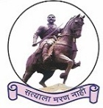
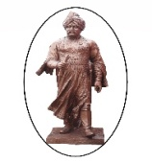

All India Shri Shivaji Memorial Society’s
College of Engineering, Pune – 1
Organizes
International Workshop
on
“Think global, act local - International trends in open science and repositories”
4 March 2019

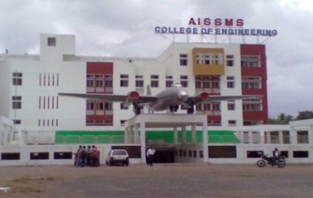
Venue
Central Library
AISSMS COLLEGE OF ENGINEERING
Kennedy Road, Pune-411001
Contact
TEL:+91-20-26058587
FAX:+91-20-26058943
E-Mail : vsdandawate@aissmscoe.comWebsite: www.aissmscoe.com

RESOURCE PERSONS

Kathleen Shearer
Executive Director, COAR
Confederation of Open Access Repositories, Canada

Prof Kazutsuna Yamaji
Professor, Digital Content and Media Sciences Research Division, Japan

Prof Miho Funamori
Professor, Information and Society Research Division Associate, Japan

Dr Hideaki Takeda
Professor, Principles of Informatics Research Division National Institute of Informatics, Japan

Dr Sunita Barve
Principal Technical Officer, NCL, Pune

===========================
ORGANIZING SECRETARY
Mrs Vrushali Dandawate
Librarian, AISSMS College of Engineering
Phone -020-26058587 Ext-1131
Mob- 09689139765
Email-vsdandawate@aissmscoe.com
PATRONS
Shri Shahu Chhatrapati, Kolhapur
President, AISSMS, Pune
Shri Malojiraje Chhatrapati
Honorary Secretary, AISSMS, Pune
OFFICE BEARERS: AISSMS PUNE
Shri Sambhajiraje Chhatrapati
Vice-President
Shri Suresh P Shinde
Honorary Joint Secretary
Shri A U Patil
Treasurer
Shri V B Patil
Chairman, Governing Council
Shri Sahebrao Jadhav
Chairman, Managing Committee

ADVISORY COMMITTEE
Dr D S Bormane
Principal, AISSMSCOE, Pune
Dr A V Waghmare
HOD Mechanical Engineering AISSMSCOE
Dr S R Parekar
HOD Civil Engineering AISSMS COE
Dr A A Godbole
HOD Electrical Engineering, AISSMCOE

ORGANISING COMMITTEE
Mr Dnyaneshwar Jadhav
Head Librarian, FLAMES University, Pune
Miss Jayashree Jagtap
Librarian, AISSMS Polytechnic, Pune
Mr Pavan Sharma Librarian, Yashaswi Education Society's IIMS, Pune

SOCIETY
All India Shri Shivaji Memorial Society (AISSMS), Pune was established in 1917 by Rajarshi Shahu Chhatrapati Maharaj of Kolhapur with the sole purpose of promoting the noble cause of education. Society runs 19 educational institutions, College of Engineering being one of them.
INSTITUTION
AISSMS College of Engineering, Pune was established in the year 1992. The College is affiliated to the University of Pune. It conducts undergraduate courses in various disciplines of engineering namely, Chemical, Civil, Computer, Electrical, Electronics, Mechanical, Mechanical Sandwich and Production Sandwich and post graduate courses in Chemical, Structure, Computer, Power Electronics and Drives, Microwave, Automotive and Design. College is located in the heart of the Pune city on a sprawling campus.
THEME
The workshop will focus on the different aspects of modern information management. COAR is a young association which unites organisations from across the world. Its core mission is to enhance greater visibility and application of research outputs through global networks of Open Access digital repositories. Moreover, COAR aims to enable every citizen in the world to get access to – and be able to benefit from – knowledge produced from publicly-funded research. This workshop will give idea about COAR work and will focus on Indian Scenario
OBJECTIVES
This workshop aims at sensitizing librarians on
Open Access repositories system and also try to focus on Open Data sets

This workshop also work on :
To raise awareness of international trends in open access, open science, and repositories
To support the adoption of interoperability practices and standards in India
To identify gaps and issues in India and develop a strategy to address gaps
TARGET AUDIENCE
The workshop Committee invites participants from India and worldwide, including practitioners, managers and researchers in library and information sciences and services, computer science, information science, web science, data science, data management, archives and archival science, museums, information technology, medicine, social sciences, education and humanities.

YOUR ATTENDANCE
All expenses, including registration fee, visas, travel and accommodation, are the responsibility of authors/presenters/participants.

ACCOMMODATION
Delegates have to arrange accommodation on their own. College will help them to book the accommodation in nearest hotel
Fees
For Indian Participants- Rs - 600/-
For International Participants $ 100

Online payment can be done for paying registration fee
Bank Name and Branch - Bank of Baroda Shivajinagar
Bank Account name- The Principal AISSMS COE Pune
Bank Account Number- 04510200000873
Bank IFSC Code Number- BARB0SHIPOO (5th Character is zero)
(Please send online payment proof via email to vsdandawate@aissmscoe.com)

LAST DATE OF REGISTRARTION : 20/02/2019

Registration Form

1.Name- ......................................

2.Designation - ..............................

3.Name of the Institution.....................

4.Address for Communication
…………………………………………………………………. ......................................................
..................................................................
...................................................................

5. Telephone No-- ................................

6 E-mail ID – ......................................

7. Name of the Bank ------------------------------
-------------------------------------------------

9. DD/ Cash ----------------------------------------------------------------------------------

10.Date:- .................................................

Signature

Note: Please send the duly filled form with registration fee through Demand Draft in favor of “Principal, AISSMS College of Engineering, Pune-1”

